


Module Code & Module Title
CS5002NT– Software Engineering

Assessment Type
20% Group Coursework

Semester
2025-2026 Autumn
30 - Credit

Group Name: Group 1
Group members
London Met ID | Student Name
 | Pratik Kattel
 | Aakansha Sedai
 | Riya Basnet
 | Soni Limbu

Assignment Due Date:
Assignment Submission Date:
Submitted To: Mr. Amit Shrestha
Word Count:
I confirm that I understand my coursework needs to be submitted online via Google Classroom under the relevant module page before the deadline in order for my assignment to be accepted and marked. I am fully aware that late submissions will be treated.

ERD
An entity relationship diagram (ERD) is a high-level conceptual data model in which data are stored in the form of real-world objects and relationship between them is shown. It gives the proper overview of the system before development which will be very beneficial for both developers and stake-holders. (Geeks, 2025)
In ERD the entities are represented by the rectangle, attributes are represented by the oval and the relationship is shown using the diamond shape. The two entities are joined through the relationship using the crow-foot notation.

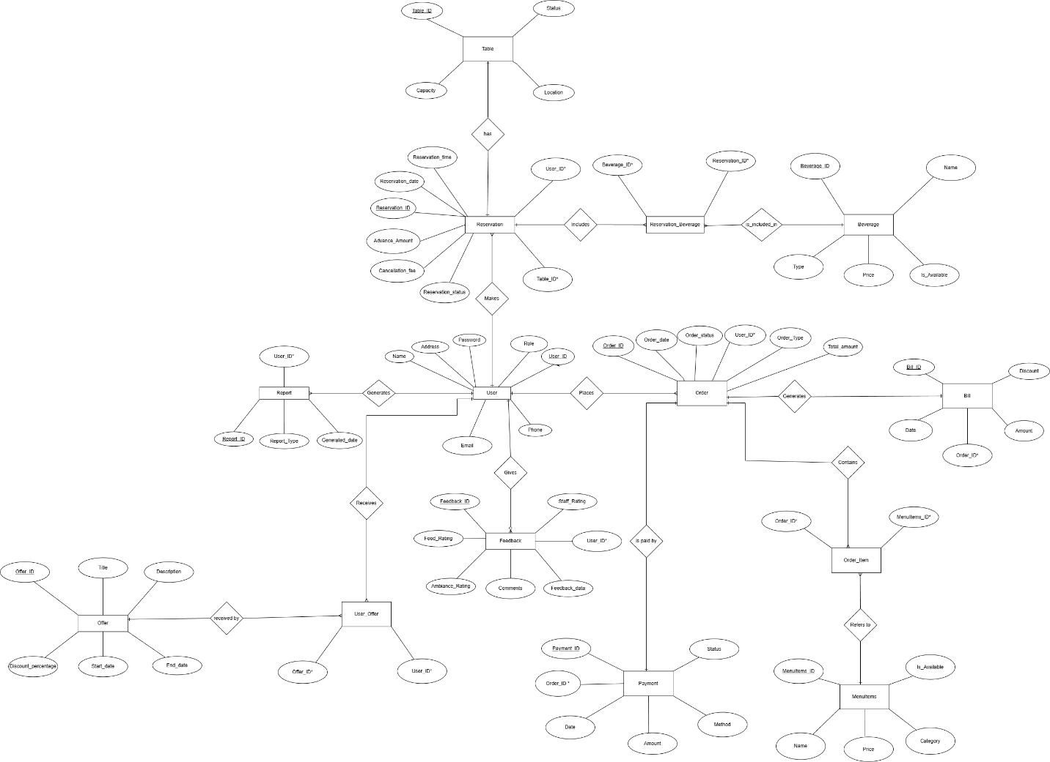

Assumptions on ERD:
The following things were assumed for designing the ERD and according to this the whole system database will be developed:
- A user can be admin, visitor as well as the member and will be distinguished based on their roles.
- A user may give the feedback.
- A user can make multiple reservations.
- One reservation refers to only one table at a specific time.
- Multiple reservations include multiple beverages.
- Multiple users receive multiple offers.

Data Dictionary
A data dictionary is a document or a specific content that includes every detail of the dataset included in the database which helps the users to understand it more clearly. A data dictionary generally includes name of the data element, data type, primary key or foreign key information, whether a particular column is optional or not, it also shows a default value if that exists in the system. Generally, the DBA (Database Administrator) communicates or uses the data dictionary. (edu, n.d.)
It also helps to prevent the data redundancy as well as the data inconsistency.
Restaurant_System = User + Table + Reservation + Beverage + Reservation_Beverage + Order + MenuItems + Order_Item + Bill + Payment + Feedback + Report + Offer + User_Offer
User
- User= {User_Details}* /* data stored in database */
- User_Details = User_ID + Name + Address + Email + Password + Role
- User_ID = Number /* Primary Key */
- Name = String
- Email = String
- Address = String
- Password = String
- Role = [“Admin”, “Member”]
Table
- Table= {Table_Details}* /* data stored in database */
- Table_Details = Table_ID + Capacity + Location + Status
- Table_ID = Number /* Primary Key */
- Capacity = Number
- Location = String
- Status = [“Available”, “Reserved”, “Occupied”]
Reservation
- Reservation= {Reservation_Details}* /* data stored in database */
- Reservation_Details = Reservation_ID + Reservation_Date + Reservation_Time + Advance_Amount + Cancellation_Fee + Reservation_Status + User_ID + Table_ID
- Reservation_ID = Number /* Primary Key */
- User_ID = Number /* Foreign Key Referencing User Table */
- Table_ID = Number /* Foreign Key Referencing Table Table */
- Reservation_Date = Date
- Reservation_Time = Date
- Advance_Amount = Decimal
- Cancellation_Fee = Decimal
- Reservation_Status = [“Confirmed”, “Cancelled”, “Pending”]
Beverage
- Beverage={Beverage_Details}* /* data stored in database */
- Beverage_Details = Beverage_ID + Name + Type + Price + Is_Available
- Beverage_ID = Number /* Primary Key */
- Name = String
- Type = String
- Price = Decimal
- Is_Available = [“Yes”, “No”]
Reservation_Beverage
- Reservation_Beverage= Reservation_ID + Beverage_ID
- Reservation_ID = Number * Foreign Key Referencing Reservation Table */
- Beverage_ID = Number * Foreign Key Referencing Beverage Table */
Order
- Order={Order_Details}* /* data stored in database */
- Order_Details = Order_ID + Order_Date + Order_Status + Order_Type + Total_Amount + User_ID
- Order_ID = Number /* Primary Key */
- User_ID= Number /* Foreign Key Referencing User Table */
- Order_Date = Date
- Order_Status = [“Pending”, “Completed”, “Cancelled”]
- Order_Type = [“Dine-in”, “Home Delivery”]
- Total_Amount = Decimal
MenuItems
- MenuItems={MenuItems_Details}* /* data stored in database */
- MenuItems_Details = MenuItems_ID + Name + Category + Price + Is_Available
- MenuItems_ID = Number /* Primary Key */
- Name = String
- Category = String
- Price = Decimal
- Is_Available = [“Yes”, “No”]
Order_Item
- Order_Item= Order_ID + MenuItems_ID
- Order_ID = Number /* Foreign Key Referencing Order Table */
- MenuItems_ID = Number /* Foreign Key Referencing MenuItems Table */
Bill
- Bill={Bill_Details}* /* data stored in database */
- Bill_Details = Bill_ID + Date + Amount + (Discount) + Order_ID
- Bill_ID = Number /* Primary Key */
- Order_ID = Number /* Foreign Key Referencing Order Table */
- Date = Date
- Amount = Decimal
- Discount = Decimal
Payment
- Payment={Payment_Details}* /* data stored in database */
- Payment_Details = Payment_ID + Date + Amount + Method + Status + Order_ID
- Payment_ID = Number /* Primary Key */
- Order_ID = Number /* Foreign Key Referencing Order Table */
- Date = Date
- Amount = Decimal
- Method = [“Cash”, “Card”, “Online”]
- Status = [“Paid”, “Unpaid”]
Feedback
- Feedback={Feedback_Details}* /* data stored in database */
- Feedback_Details = Feedback_ID + Food_Rating + Staff_Rating + Ambiance_Rating + (Comments) + Feedback_Date + User_ID
- Feedback_ID = Number /* Primary Key */
- Food_Rating = Number
- Staff_Rating = Number
- Ambiance_Rating = Number
- Comments = String
- Feedback_Date = Date
- User_ID = Number /* Foreign Key Referencing User Table */
Report
- Report={Report_Details}* /* data stored in database */
- Report_Details = Report_ID + Report_Type + Generated_Date + User_ID
- Report_ID = Number /* Primary Key */
- Report_Type = String
- Generated_Date = Date
- User_ID = Number /* Foreign Key Referencing User Table */
Offer
- Offer={Offer_Details}* /* data stored in database */
- Offer_Details = Offer_ID + Title + Description + Discount_Percentage + Start_Date + End_Date
- Offer_ID = Number /* Primary Key */
- Title = String
- Description = String
- Discount_Percentage = Decimal
- Start_Date = Date
- End_Date = Date

User_Offer
- User_Offer= User_ID + Offer_ID
- User_ID = Number /* Foreign Key Referencing User Table */
- Offer_ID = Number /* Foreign Key Referencing Offer Table */

Process Specification
A process specification is a detailed description about how a certain function or business rules works in the system. It gives a wide knowledge about the complete process of converting input to output. It is often created as per the Data Flow Diagram (DFD). (Geeks, 2025)
The several processes included in the system of Gokyo Bistro are as follows:
Login and Registration
Process ID:1
Process Name: Login and Registration.
Description: This process controls the login and registration for the system. It allows multiple users (admin, members) to register to the system and login using the proper login details. The system checks the details for every user’s before giving any access. Visitors doesn’t need to login or register to the system, they can by-pass it.
Process Input:
- Registration details: Username, Email, Password, Address
- Login credentials: Email, Password.
Process Output:
- Registration success or failure message.
- Successful login message.
- User dashboard based on role.
- Invalid login credentials error.
Process Logic:
- User submits the registration form with several required fields such as username, email, password and address.
- The system validates the entered details.
- If the entered registration details are valid then it stores the user’s details in database.
- If the registration details are incorrect then a certain registration error is thrown.
- User provides their login credentials (Email and Password) through the login form to login into the system.
- The system validates the login credentials.
- If login credentials are valid then the system redirects them to their respective dashboards
- If login credentials are invalid then invalid login credentials error is thrown.
- Visitors bypass the login and registration process.

Table Reservation
Process ID:2
Process Name: Table Reservation.
Description: This process controls the flow of booking or reservation of tables by users. It allows the visitors and members to reserve a table for a certain date and time. The user enters the date and table number for reservation and the system verifies if the table is available or not. Members can easily reserve the table using their login credentials but visitors don’t have any kind of credentials so they can book the table by using their name, phone number and email. In-order to confirm the booking or reservation an advance of 1200 is required to pay through cash or online. After the successful payment booking will be confirmed and unique booking id will be generated and also the booking details will be stored in the database.
Process Input:
- Members: Login credentials, Reservation_date, Reservation_time, Advance_Amount, Table_ID.
- Visitors: Name, Phone Number, Email.
Process Output:
- Reservation confirmation or failure message.
- Reserved table details and ID if reservation is confirmed.
- Booking Reference number for visitors.
Process Logic:
- Members enter the table_id, reservation date and time and also pays 1200 as advance payment using specific payment method.
- Visitors enters their name, phone number, email, table_id, reservation date and time and pays 1200 as advance using credit card.
- The system validates the payment made by the users.
- If the payment is un-successful then a payment error message is displayed.
- The system checks availability of the chosen table at that particular time.
- If the table is available then the reservation will be confirmed and the booking details will be saved into the database. A unique reservation ID will also be generated and will be shown to the user along with the details of the reserved table.
- If the specific table is not available for booking then a booking error will be displayed to the user.

Cancel Reservation
Process ID:3
Process Name: Reservation Cancellation.
Description: This process handles the request for cancelling the reservation by the user. It receives the user’s cancellation request and deletes the booking details from the database. Also, the advance fee is returned to the user fully or by deducting some amount.
Process input:
- Members: Cancellation request with some other details such as their login credentials and the reservation id.
- Visitors: Cancellation request with other details such as their booking reference number and phone number or email.
Process output:
- Cancellation successful message.
- Refund details.
Process Logic:
- Members submits the cancellation request with details such as their login credentials anf reservation id.
- Visitors submits the cancellation request with details such as their booking reference number and phone number or email.
- The system receives the cancellation request and validates it.
- If the cancellation request is valid and the entered details are correct then the reservation will be successfully cancelled.
- After successful cancellation of request the booked date and the cancelled date will be compared by the system.
- If the cancelled date and the booked date are same then 500 will be deducted from the advance amount and will be returned to the user.
- If the cancelled date is before the booked date, then the full advance payment is returned to the user.

Set Beverage choice
Process ID:4
Process Name: Set Beverage Choice
Description: This process sets the beverage chose by the user during the booking time or even also after booking. This process will set the user’s beverage choice and stores in the database system.
Process Input:
- User’s beverage choice from the available menu including beverage id and name.
Process output:
- Beverage choice recorded into the database system for the user.
Process Logic:
- The user chooses a beverage from the MenuItems.
- The system verifies whether the chosen beverage is available or not.
- If the beverage is not available then the user will be informed that the beverage is currently out of stock.
- If the beverage is available then it will be confirmed and will be stored in the database for a particular user.

Bill generation
ProcessID:5
Process Name: Bill generation
Description: This process allows the admin to generate a bill for any type of orders. The bill is generated for a specific order. The total amount of all the foods and beverages will be included into the bill and a certain percentage of discount is also applied if available.
Process Input:
- Order details including the MenuItems and their specific prices.
- Offer details if available.
Process Output:
- Bill including the total payable amount and discount amount if available.
Process Logic:
- Admin starts the bill generation process.
- System retrieves the order_ID and order details from the database.
- The system verifies if any kind of offer is available or not.
- The system calculates the total amount of the order.
- If there exists any kind of offers then the discount will be subtracted from the total amount otherwise total amount will be displayed to the user as payable amount.
Rating and feedback
ProcessID:6
Process Name: Rating and feedback
Description: This process allows the users (both visitors and members) to rate the food, ambiance, staff’s behaviour and also allows user to add the comment. It will collect the user’s rating and store it in the database system.
Process Input:
- Rating for staff, ambiance and food from the user.
- Feedback or comments from the user.
Process Output:
- Feedback confirmation or error message.
- Store the feedback into the database if confirmed.
Process Logic:
- User enters the orderID or Booking ID for confirmation.
- If user’s orderID or booking ID is not valid then an error message, “You cannot rate the foods or staff without valid order or booking” will be shown to the user.
- If the orderID or Booking ID is valid then user can give their ratings and feedbacks.
- After that rating confirmation message will be displayed and the feedbacks and rating will be stored into the database.

